Entry Form
NAME______________________________________ AGE_______
ADDRESS___________________________________________________________
PHONE_______________________________ Special Needs Child? Yes____; No_____.
TAG NUMBER | LAMB OR GOAT | BORN AND BRED (YES or NO) | ENTRY FEE ($10 per Head) | LATE ENTRY FEE (Additional $10 per Head)

TOTAL FEES $
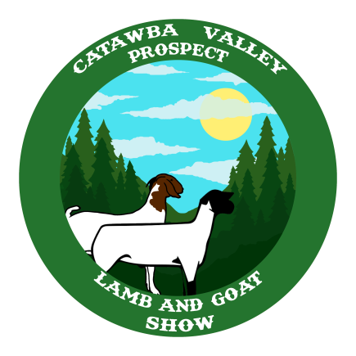
PLEASE MAKE CHECKS AND RETURN BY JUNE 7 TO:
CATAWBA VALLEY PROSPECT LAMB SHOW
CATAWBA COUNTY EXTENSION OFFICE
P.O. BOX 389
NEWTON, NC 28658
or email completed form to: NScline@ncsu.edu
or text completed form to: 405.219.1902
Checks must be mailed or dropped off at the Extension Office.
GPS Address: 1175 South Brady Ave. Newton, NC

